SimpleWebEasyORM web application screenshots

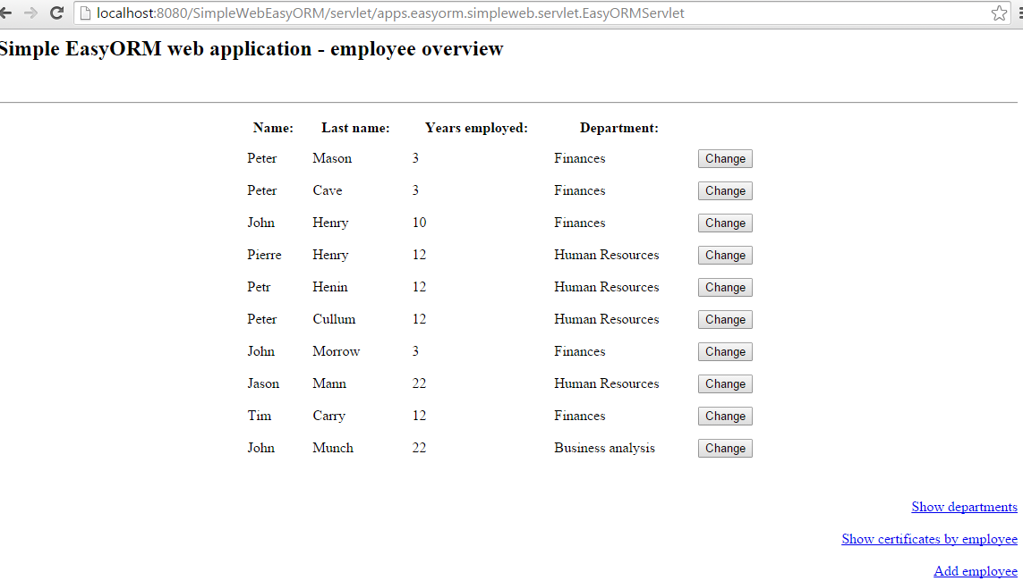

Figure 1) Employee overview

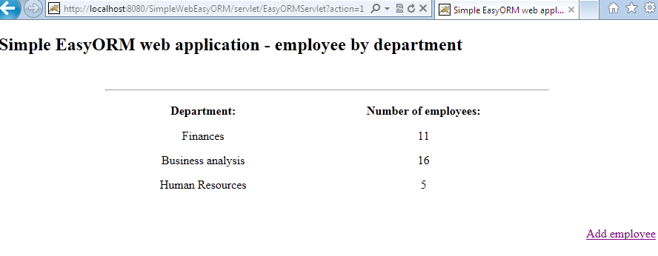

Figure 2) Employee by department

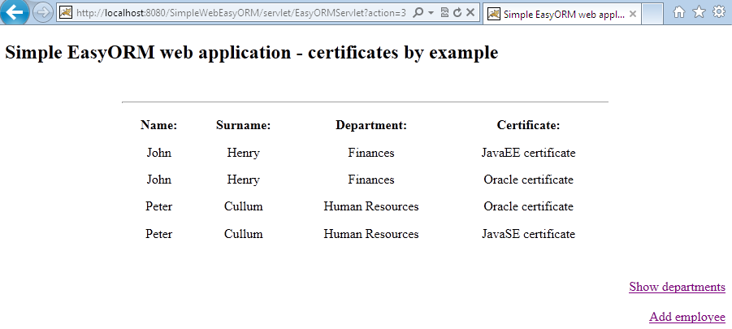

Figure 3) Certificates by employee

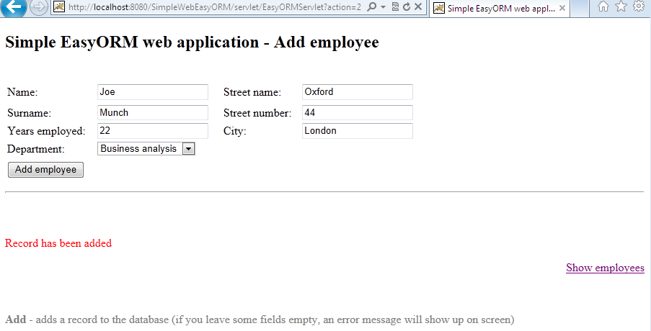

Figure 4) Add employee form

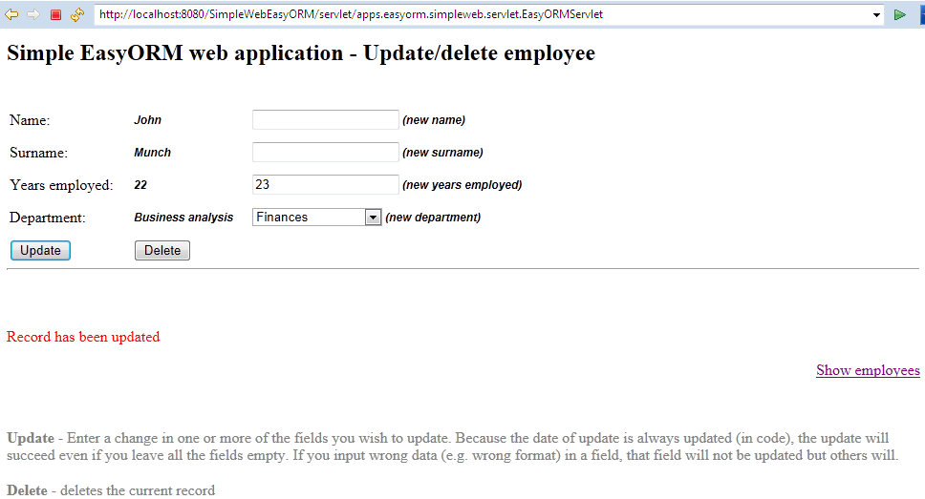

Figure 5) Update/Delete employee form

